TY B.Tech. – ARTIFICIAL INTELLIGENCE AND MACHINE LEARNING
PRACTICAL ASSIGNMENT
1. Student Details
Student Name | Abhay Rajendra Gaikwad
PRN | 202401100146
Branch | Computer Engineering
Division | E
Batch | E2
Roll No. | 341
Date of Submission | 29-10-2026
2. Practical Details
Practical No. | 03
Practical Title | Performance Evaluation of Regression Model
Date Performed | 27-08-2026
Faculty Name | Khushal Khairnar

3. Problem Statement
- Develop regression models for a real-world application and evaluate their performance using appropriate regression metrics.
2. Implement and analyze the performance of Gradient Descent optimization for Linear Regression.
Application selected: Predicting diabetes disease progression using clinical measurements and comparing multiple regression algorithms.
The practical uses the diabetes dataset available through the Python scikit-learn library. Different regression models are trained and tested on the same dataset, and their performance is evaluated using Mean Absolute Error (MAE), Mean Squared Error (MSE), Root Mean Squared Error (RMSE), and the coefficient of determination (R^2).
Batch Gradient Descent is also implemented manually to study how the learning rate, number of iterations, and parameter updates influence the optimization process.
4. Objectives
- To understand the basic concepts and applications of regression in machine learning.
- To develop regression models for a real-world prediction problem.
- To implement Linear Regression, Decision Tree Regression, Random Forest Regression, and Gradient Boosting Regression.

- To evaluate regression models using MAE, MSE, RMSE, and (R^2) score.
- To implement Batch Gradient Descent for Linear Regression without using a ready-made optimization function.
- To analyze the convergence of Gradient Descent using a training-loss graph.
- To compare the prediction accuracy and computational performance of different regression algorithms.
- To identify a suitable regression model based on experimental results.
5. Expected Learning Outcomes
- Understand how regression models predict continuous numerical values.
- Prepare datasets for training and testing machine-learning models.
- Select and implement appropriate regression algorithms for a given problem.
- Calculate and interpret regression evaluation metrics.
- Explain the mathematical working of Gradient Descent.
- Understand the effect of learning rate, feature scaling, and epochs on model convergence.
- Compare regression models based on experimental results and identify their limitations.
6. Theory / Concept:
6.1 Regression: Regression is a supervised machine-learning technique used to predict continuous numerical values from input features. In this practical, regression models predict diabetes disease progression using clinical measurements.
6.2 Linear Regression: Linear Regression predicts the target using a linear relationship between input features and output. It minimizes prediction errors to find suitable model coefficients.
6.3 Decision Tree Regression: Decision Tree Regression divides data into smaller regions using decision rules and predicts a numerical value for each region. It can capture nonlinear relationships.
6.4 Random Forest Regression: Random Forest combines multiple decision trees and averages their predictions to improve prediction stability and reduce overfitting.
6.5 Gradient Boosting Regression: Gradient Boosting builds decision trees sequentially, with each new tree attempting to reduce the errors made by the existing model.
6.6 Gradient Descent: Gradient Descent is an optimization algorithm that minimizes the loss function by repeatedly updating model weights and bias in the direction that reduces prediction error.
The Mean Squared Error loss function is:

$$J\left(w,b\right)=\frac{1}{n}\sum_{i=1}^{n}{}{\left(\hat{}y_{i}-y_{i}\right)}^{2}$$
6.7 Evaluation Metrics:
- MAE: Average absolute difference between actual and predicted values.
- MSE: Average squared prediction error.
- RMSE: Square root of MSE, expressed in the target's units.
- (R^2) Score: Measures how well the model explains variation in the target. Lower MAE, MSE and RMSE and generally higher (R^2) indicate better performance.
7. Algorithm / Pseudocode:

7.1 Algorithm for Regression Model Evaluation
Step 1: Start.
Step 2: Import the required Python libraries.
Step 3: Load the diabetes dataset.
Step 4: Separate the input features (X) and target variable (y).
Step 5: Divide the dataset into training and testing sets using an 80:20 ratio.
Step 6: Initialize Linear Regression, Decision Tree, Random Forest, and Gradient Boosting models.
Step 7: Train each model using the training dataset.
Step 8: Predict the target values for the testing dataset.
Step 9: Calculate MAE, MSE, RMSE, (R^2), and execution time.
Step 10: Implement Batch Gradient Descent for Linear Regression.
Step 11: Plot the training-loss curve and compare the model results.
Step 12: Identify the model with the lowest test RMSE and stop.

7.2 Algorithm for Batch Gradient Descent
Step 1: Start.
Step 2: Standardize the training input features and target variable.
Step 3: Initialize all weights and bias to zero.

Step 4: Calculate predictions using the current weights and bias.
Step 5: Calculate the prediction errors.
Step 6: Calculate the gradients of the Mean Squared Error with respect to the weights and bias.
Step 7: Update weights and bias using the learning rate.
Step 8: Repeat Steps 4–7 for the specified number of epochs.
Step 9: Record the training loss at regular intervals.
Step 10: Predict values for the test dataset and convert them back to the original target scale.
Step 11: Calculate evaluation metrics and compare the results with standard Linear Regression.
Step 12: Stop.
08. Technology / Tools / Libraries Used
Technology / Tool | Purpose
Python | Implementation of regression algorithms
Jupyter Notebook / VS Code | Writing and executing Python code
NumPy | Mathematical calculations and gradient updates
Pandas | Storing and displaying evaluation results
Matplotlib | Plotting the loss curve and prediction graph
scikit-learn | Loading the dataset, splitting data, training models, and calculating metrics

09. Implementation / GitHub Repository
Particular | Details
GitHub Repository URL | https://github.com/AbhayGaikwad05/AI-Problem-Solving-Through-Search.git
Repository Name | AI-Problem-Solving-Through-Search
Branch Used | main
Commit ID / Latest Commit | ed22fd9
Date of Last Commit | 11-09-2026

10. Test Cases / Input and Output:

Test Case 1: Dataset Loading
Input: Load the diabetes dataset from scikit-learn.
Expected output:
- Total records: 442
- Input features: 10
- Target variables: 1
The dataset is successfully loaded with the clinical measurements as inputs and the disease-progression measure as the target.

Test Case 2: Training and Testing Split
Input: Test size = 0.20 and random state = 42.
Expected output:
- Training records: 353
- Testing records: 89
The same split is used for all evaluated models to ensure a fair comparison.

Test Case 3: Regression Model Evaluation
Input: Training data and testing data.
Expected output: The program prints MAE, MSE, RMSE, \(R^2\), and execution time for each of the five model variants.
The models are compared according to their errors and test-set predictive performance.

Test Case 4: Gradient Descent Optimization
Input:
- Learning rate: 0.05
- Number of epochs: 5000
- Initial weights: 0
- Initial bias: 0
Expected output: The program calculates gradient updates, records training loss, generates test predictions, and evaluates the resulting model using regression metrics.

Test Case 5: Visualization
Input: The trained Gradient Descent model and the best model determined by test RMSE.
Expected output:
- A graph showing training loss against epochs.
- A graph comparing actual and predicted target values.
- A CSV file containing the model evaluation results.
11. Results / Observations:
The Python implementation was executed using the diabetes dataset with a fixed random state of 42. The following values were obtained from the test set.
Model | MAE | MSE | RMSE | (R^2) score
Gradient Boosting | 42.549 | 2727.517 | 52.226 | 0.485
Random Forest | 43.274 | 2860.393 | 53.483 | 0.460
Linear Regression (Batch GD) | 42.795 | 2899.856 | 53.850 | 0.453
Linear Regression | 42.794 | 2900.194 | 53.853 | 0.453
Decision Tree | 47.045 | 3568.965 | 59.741 | 0.326

Top of Form
Bottom of Form
Screenshots / Graphs / Output:
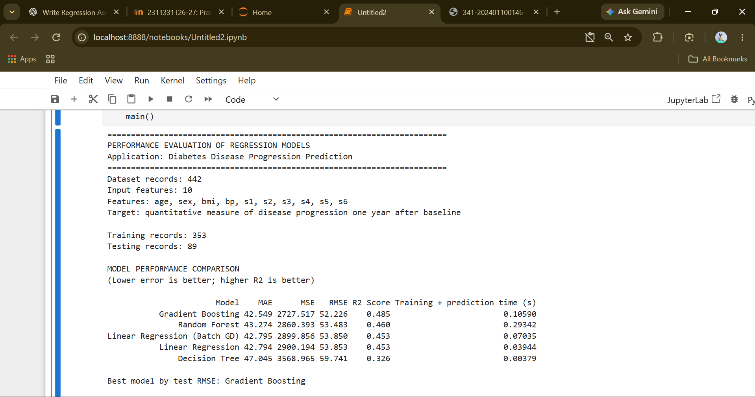

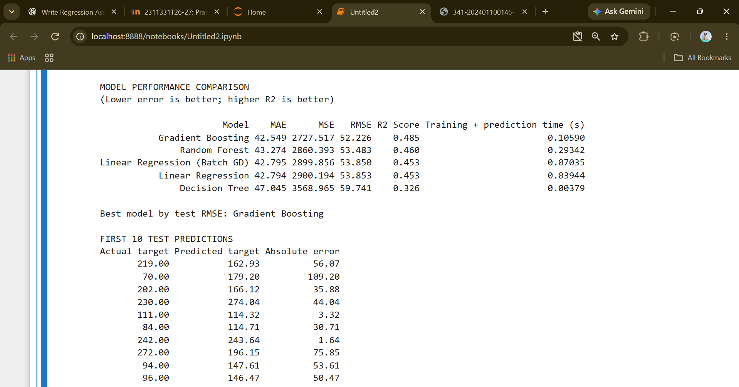

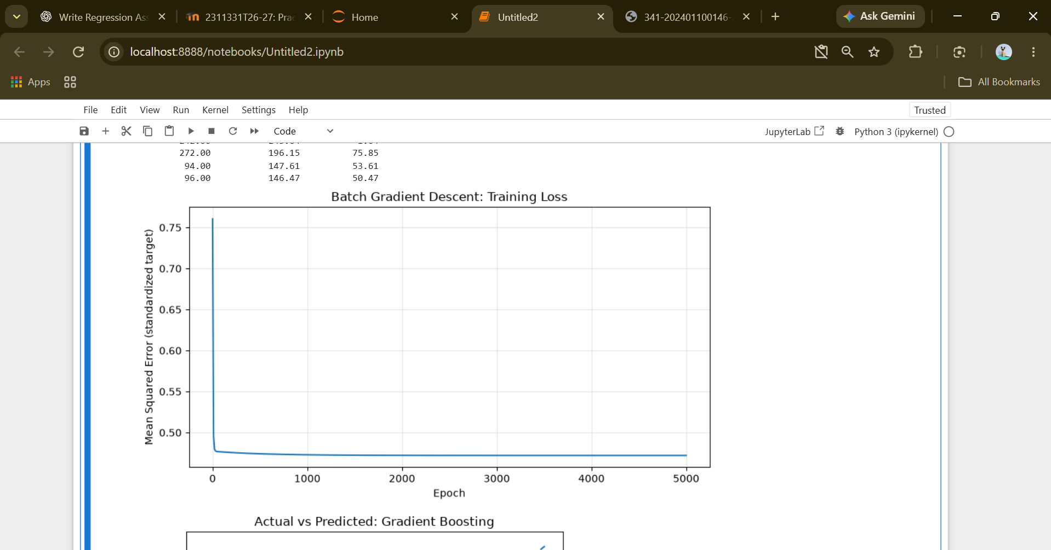
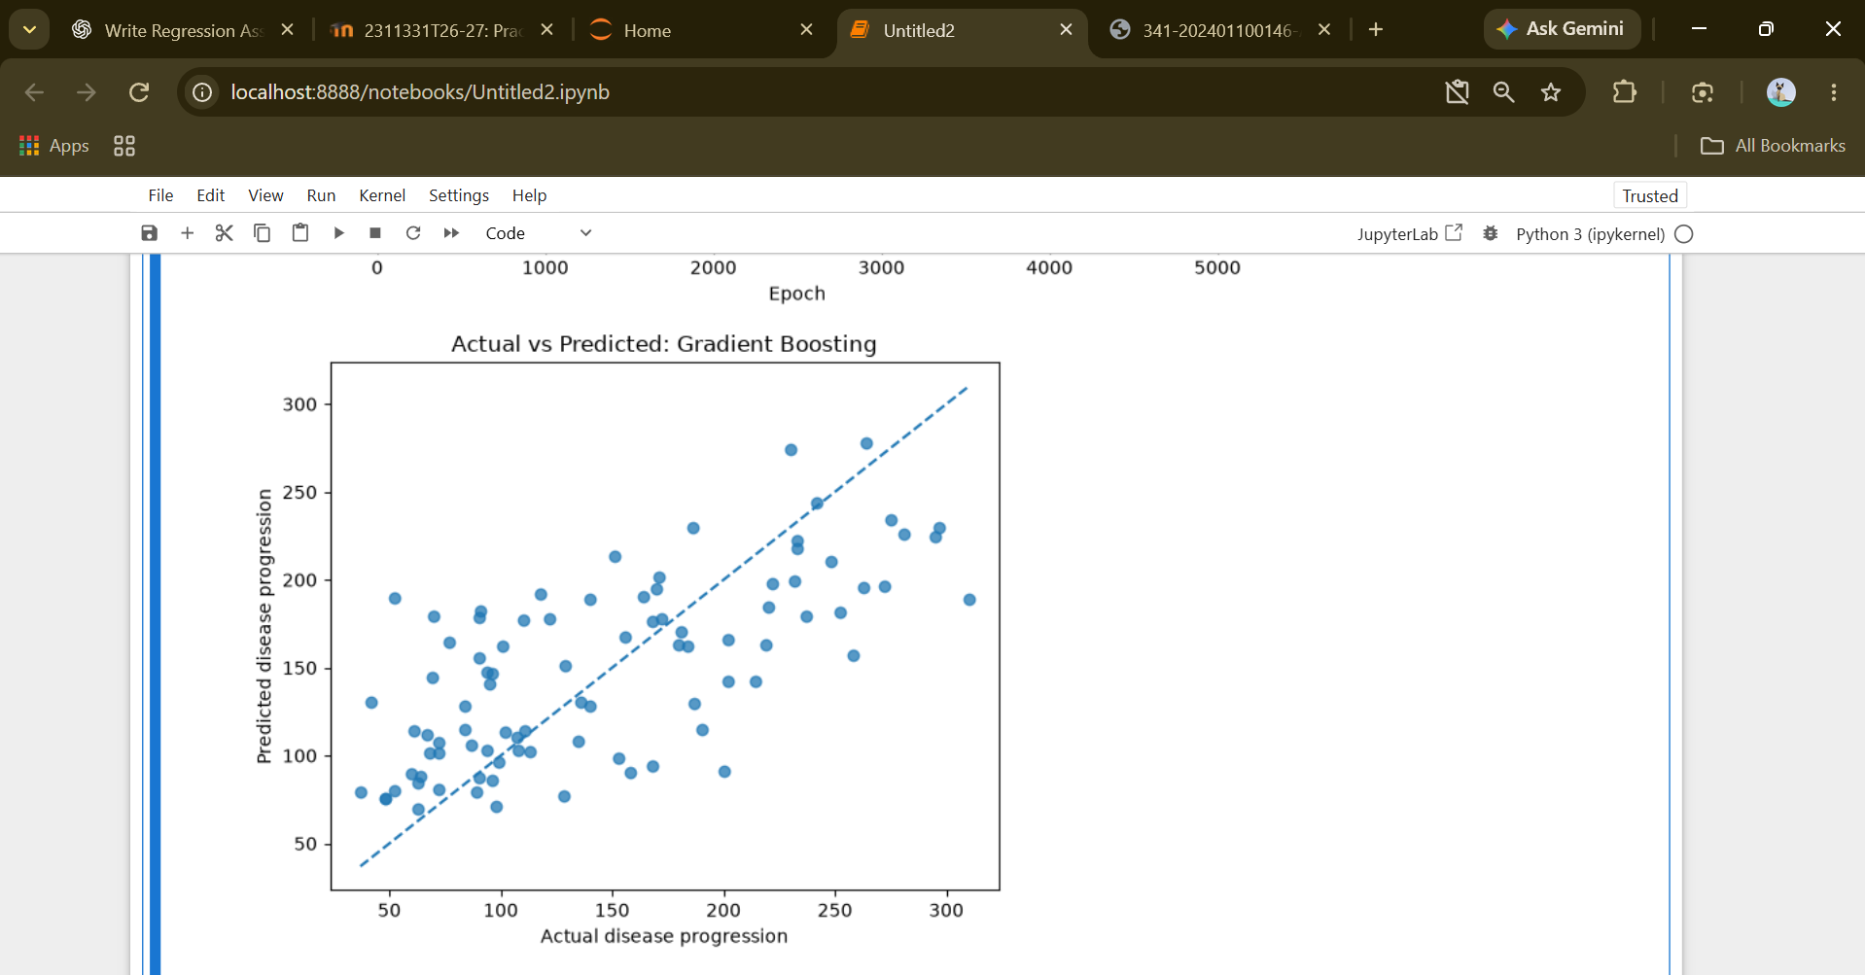

12. Performance Evaluation / Analysis:

12.1 Comparative Analysis of Regression Models
The performance of the regression models was evaluated using MAE, MSE, RMSE, and (R^2). All models used the same training and testing split, making their results directly comparable for this experiment.
Gradient Boosting Regression: Gradient Boosting achieved the lowest test RMSE of 52.223 and the highest (R^2) score of 0.485 among the tested models. This suggests that its ensemble of sequentially trained trees captured useful patterns in the dataset.
Random Forest Regression: Random Forest achieved an RMSE of 53.483 and an (R^2) score of 0.460. Averaging multiple trees helped it perform better than the single Decision Tree in this experiment.
Linear Regression: Standard Linear Regression achieved an RMSE of 53.853 and an (R^2) score of 0.453. It provides a straightforward baseline, although it may not capture all nonlinear relationships in the dataset.
Linear Regression using Batch Gradient Descent: The manually implemented Gradient Descent model achieved an RMSE of 53.850 and an (R^2) score of 0.453. Its results were almost identical to those of standard Linear Regression, showing that iterative optimization can successfully learn the parameters of a linear model.
Decision Tree Regression: The Decision Tree achieved an RMSE of 59.741 and an (R^2) score of 0.326. Its performance was weaker than the other evaluated models with the selected tree configuration.

12.2 Analysis of Gradient Descent
Batch Gradient Descent optimizes Linear Regression by repeatedly updating the weights and bias in the direction that reduces the Mean Squared Error.
The following factors influence its performance:
- Learning rate: Determines the size of each parameter update. A learning rate that is too large can result in unstable updates, while an excessively small rate can slow convergence.
- Number of epochs: Determines how many times the algorithm updates the parameters. More epochs can improve convergence, but additional iterations do not guarantee better test performance.
- Feature scaling: Prevents differences in feature magnitudes from making optimization difficult and helps the algorithm converge more reliably.
- Loss function: Mean Squared Error measures the training prediction error and guides the parameter updates.
- Execution time: Depends on the dataset size, number of features, number of epochs, and the computer's computational resources.
The loss graph should generally show a decrease in training loss followed by stabilization when the chosen settings allow convergence.

12.3 Critical Evaluation
The results indicate that Gradient Boosting was the most effective model on this particular test split. However, a single train-test split does not guarantee that the same model will be best for every dataset or split.
The comparison also has limitations. The dataset is relatively small, only one set of hyperparameters was tested for each tree-based model, and the benchmark dataset may not represent clinical data encountered in real-world healthcare settings.
Further evaluation could use cross-validation and systematic hyperparameter tuning. Such experiments would provide a more robust assessment of the models' generalization performance.
Overall finding: Model selection should be based on measured test performance, the intended application, interpretability, computational requirements, and the consequences of prediction errors rather than on the algorithm's name alone.
13. Conclusion:
This practical successfully implemented and evaluated multiple regression models for a real-world numerical prediction task using the diabetes dataset. Linear Regression, Decision Tree Regression, Random Forest Regression, and Gradient Boosting Regression were trained and evaluated using MAE, MSE, RMSE, and (R^2) score.
The practical also demonstrated the manual implementation of Batch Gradient Descent for Linear Regression. The model's weights and bias were updated iteratively using gradients calculated from Mean Squared Error. Feature scaling and the learning rate were used to support the optimization process, and a training-loss graph was generated to analyze convergence.
Among the tested models, Gradient Boosting achieved the lowest test RMSE of 52.223, while Random Forest ranked second. The manually implemented Gradient Descent model produced results almost identical to standard Linear Regression.
Thus, the practical demonstrated the importance of selecting appropriate regression algorithms, evaluating them using suitable metrics, and analyzing optimization behaviour. The experiment also showed that model performance must be verified using held-out data and interpreted in the context of dataset limitations.
14. Implementation / Source Code
# ============================================================
# TY B.Tech. AIML - Practical Assignment 03
# Performance Evaluation of Regression Models
# Application: Diabetes Disease Progression Prediction
# ============================================================

import time
import numpy as np
import pandas as pd
import matplotlib.pyplot as plt

from sklearn.datasets import load_diabetes
from sklearn.model_selection import train_test_split
from sklearn.preprocessing import StandardScaler
from sklearn.pipeline import make_pipeline

from sklearn.linear_model import LinearRegression
from sklearn.tree import DecisionTreeRegressor
from sklearn.ensemble import (
RandomForestRegressor,
GradientBoostingRegressor
)

from sklearn.metrics import (
mean_absolute_error,
mean_squared_error,
r2_score
)

# ------------------------------------------------------------
# 1. Evaluation Metrics
# ------------------------------------------------------------

def regression_metrics(y_true, y_pred):
"""Calculate common regression evaluation metrics."""

mae = mean_absolute_error(y_true, y_pred)

mse = mean_squared_error(y_true, y_pred)

rmse = np.sqrt(mse)

r2 = r2_score(y_true, y_pred)

return {
"MAE": mae,
"MSE": mse,
"RMSE": rmse,
"R2 Score": r2
}

# ------------------------------------------------------------
# 2. Batch Gradient Descent Implementation
# ------------------------------------------------------------

def batch_gradient_descent(
X,
y,
learning_rate=0.05,
epochs=5000
):
"""
Train Linear Regression using Batch Gradient Descent.

The feature scaler and target scaler are fitted only on
the training data supplied to this function.
"""

# Standardize input features
x_scaler = StandardScaler()
X_scaled = x_scaler.fit_transform(X)

# Standardize target variable
y_scaler = StandardScaler()
y_scaled = y_scaler.fit_transform(
np.asarray(y).reshape(-1, 1)
).ravel()

n_samples, n_features = X_scaled.shape

# Initialize weights and bias
weights = np.zeros(n_features, dtype=float)
bias = 0.0

losses = []

# Batch Gradient Descent
for epoch in range(epochs):

# Calculate predictions
predictions = X_scaled @ weights + bias

# Calculate prediction errors
errors = predictions - y_scaled

# Calculate gradients
dw = (2 / n_samples) * (
X_scaled.T @ errors
)

db = (2 / n_samples) * np.sum(errors)

# Update weights and bias
weights -= learning_rate * dw
bias -= learning_rate * db

# Store loss periodically
if epoch % 10 == 0 or epoch == epochs - 1:

updated_predictions = (
X_scaled @ weights + bias
)

loss = np.mean(
(updated_predictions - y_scaled) ** 2
)

losses.append(loss)

return (
x_scaler,
y_scaler,
weights,
bias,
losses
)

# ------------------------------------------------------------
# 3. Predict Using the Gradient Descent Model
# ------------------------------------------------------------

def gradient_descent_predict(
X,
x_scaler,
y_scaler,
weights,
bias
):
"""Generate predictions on the original target scale."""

X_scaled = x_scaler.transform(X)

predicted_scaled = X_scaled @ weights + bias

predictions = y_scaler.inverse_transform(
predicted_scaled.reshape(-1, 1)
).ravel()

return predictions

# ------------------------------------------------------------
# 4. Main Program
# ------------------------------------------------------------

def main():

# Load the dataset
dataset = load_diabetes(as_frame=True)

X = dataset.data
y = dataset.target

print("=" * 72)
print("PERFORMANCE EVALUATION OF REGRESSION MODELS")
print("Application: Diabetes Disease Progression Prediction")
print("=" * 72)

print("Dataset records:", X.shape[0])
print("Input features:", X.shape[1])
print("Features:", ", ".join(X.columns))

print(
"Target: quantitative measure of disease progression "
"one year after baseline"
)

# --------------------------------------------------------
# Train-Test Split
# --------------------------------------------------------

X_train, X_test, y_train, y_test = train_test_split(
X,
y,
test_size=0.20,
random_state=42
)

print("\nTraining records:", len(X_train))
print("Testing records:", len(X_test))

# --------------------------------------------------------
# Define Standard Regression Models
# --------------------------------------------------------

models = {

"Linear Regression": make_pipeline(
StandardScaler(),
LinearRegression()
),

"Decision Tree": DecisionTreeRegressor(
max_depth=4,
random_state=42
),

"Random Forest": RandomForestRegressor(
n_estimators=200,
max_depth=5,
random_state=42
),

"Gradient Boosting": GradientBoostingRegressor(
n_estimators=150,
learning_rate=0.04,
max_depth=2,
random_state=42
)
}

rows = []
predictions_by_model = {}

# --------------------------------------------------------
# Train and Evaluate the Standard Models
# --------------------------------------------------------

for name, model in models.items():

start_time = time.perf_counter()

# Train the model
model.fit(X_train, y_train)

# Make test predictions
y_pred = model.predict(X_test)

end_time = time.perf_counter()

elapsed_time = end_time - start_time

# Calculate metrics
metrics = regression_metrics(y_test, y_pred)

metrics["Model"] = name

metrics["Training + prediction time (s)"] = (
elapsed_time
)

rows.append(metrics)

predictions_by_model[name] = y_pred

# --------------------------------------------------------
# Train the Manual Batch Gradient Descent Model
# --------------------------------------------------------

start_time = time.perf_counter()

(
x_scaler,
y_scaler,
weights,
bias,
losses
) = batch_gradient_descent(
X_train.to_numpy(),
y_train.to_numpy(),
learning_rate=0.05,
epochs=5000
)

training_time = time.perf_counter() - start_time

# Generate test predictions
start_time = time.perf_counter()

gd_pred = gradient_descent_predict(
X_test.to_numpy(),
x_scaler,
y_scaler,
weights,
bias
)

prediction_time = time.perf_counter() - start_time

gd_metrics = regression_metrics(y_test, gd_pred)

gd_metrics["Model"] = "Linear Regression (Batch GD)"

gd_metrics["Training + prediction time (s)"] = (
training_time + prediction_time
)

rows.append(gd_metrics)

predictions_by_model[
"Linear Regression (Batch GD)"
] = gd_pred

# --------------------------------------------------------
# Display Model Comparison
# --------------------------------------------------------

results = pd.DataFrame(rows)

results = results[
[
"Model",
"MAE",
"MSE",
"RMSE",
"R2 Score",
"Training + prediction time (s)"
]
]

results = results.sort_values("RMSE")

print("\nMODEL PERFORMANCE COMPARISON")
print("(Lower error is better; higher R2 is better)\n")

print(
results.to_string(
index=False,
formatters={
"MAE": "{:.3f}".format,
"MSE": "{:.3f}".format,
"RMSE": "{:.3f}".format,
"R2 Score": "{:.3f}".format,
"Training + prediction time (s)": "{:.5f}".format
}
)
)

# --------------------------------------------------------
# Display Sample Test Predictions
# --------------------------------------------------------

best_model_name = results.iloc[0]["Model"]

best_predictions = predictions_by_model[
best_model_name
]

sample = pd.DataFrame({
"Actual target": y_test.to_numpy()[:10],
"Predicted target": best_predictions[:10]
})

sample["Absolute error"] = np.abs(
sample["Actual target"] -
sample["Predicted target"]
)

print("\nBest model by test RMSE:", best_model_name)

print("\nFIRST 10 TEST PREDICTIONS")

print(
sample.to_string(
index=False,
formatters={
"Actual target": "{:.2f}".format,
"Predicted target": "{:.2f}".format,
"Absolute error": "{:.2f}".format
}
)
)

# --------------------------------------------------------
# Plot 1: Gradient Descent Training Loss
# --------------------------------------------------------

plt.figure(figsize=(8, 4.5))

plt.plot(
np.arange(len(losses)) * 10,
losses)

plt.title("Batch Gradient Descent: Training Loss")

plt.xlabel("Epoch")

plt.ylabel(
"Mean Squared Error (standardized target)"
)

plt.grid(True, alpha=0.3)

plt.tight_layout()

plt.savefig(
"gradient_descent_loss.png",
dpi=150
)

plt.show()

# --------------------------------------------------------
# Plot 2: Actual vs Predicted Values
# --------------------------------------------------------

plt.figure(figsize=(6, 5))

plt.scatter(
y_test,
best_predictions,
alpha=0.75
)

lower = min(
float(y_test.min()),
float(np.min(best_predictions))
)

upper = max(
float(y_test.max()),
float(np.max(best_predictions))
)

# Ideal prediction reference line
plt.plot(

[lower, upper],
[lower, upper],
linestyle="--"
)

plt.title(
f"Actual vs Predicted: {best_model_name}"
)

plt.xlabel("Actual disease progression")

plt.ylabel("Predicted disease progression")

plt.tight_layout()

plt.savefig(
"actual_vs_predicted.png",
dpi=150
)

plt.show()

# --------------------------------------------------------
# Save the Evaluation Results
# --------------------------------------------------------

results.to_csv(
"regression_model_metrics.csv",
index=False
)

print("\nSaved graph: gradient_descent_loss.png")
print("Saved graph: actual_vs_predicted.png")
print("Saved table: regression_model_metrics.csv")

# ------------------------------------------------------------
# Program Entry Point
# ------------------------------------------------------------

if __name__ == "__main__":
main()

15. Student Declaration

I hereby declare that the above practical work has been completed by me and that the implementation, analysis, and answers are my own work.

Student Name | PRN | Signature
Abhay R. Gaikwad | 202401100146 | 

